Итоговая работа по английскому языку в 4 классе за 2018- 2019 учебный год
1. Послушай, что говорят Марк и Стив о своих классных комнатах. Соотнеси описание их комнат с номерами картинок.

Mark _____
Steve_____
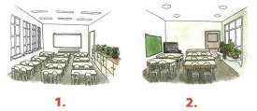

2. Чтение. Прочитай письмо Бетти. Обведи слово Тrue, если предложение верное и False, если неверное. (letter - письмо, want - хотеть)

Dear Kathy,
It is Friday now and I am at home. My brother Jimmy is reading a book but I don't want to read , I want to write a letter to you, Kathy. I want to tell you about what my family and I do at weekends. On Saturday we get up at 10 o'clock and have a big breakfast together. After breakfast we take our dog for a walk in the park. He likes to run there with other dogs. After the walk my father takes Jimmy to his tennis lesson and my mother takes me to my piano lesson. When we finish our lessons, we come home and have lunch. My mum usually cooks it and my dad sometimes helps her. After lunch Jimmy and I do our homework. In the evening we often go to the cinema or watch interesting programmes on TV. On Sunday Jimmy and I never do our homework, because we meet our friends. Jimmy often plays football with his friends and I sometimes go to the swimming pool. On Sunday evening we are always at home together and I love this time.
Love,
Betty
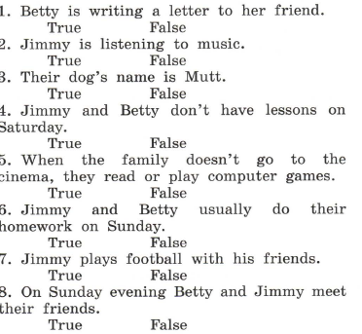
3. Впиши слова из рамки в соответствующую графу таблицы в соответствии с произношением окончания –ed.
4. Выбери и обведи нужные формы прилагательных, чтобы закончить предложения.
1. The green apples were (tastier/ the tastiest) than the red apples.
2. I think football is (more interesting/the most interesting) game of all ball games.
3. Last Saturday was (rainier/the rainiest) than last Sunday.
4. Rex is (clever/the cleverest) of all my pets.
5. Jane’s answer was (worse/the worst) of all.
5. Напиши глаголы в этих предложениях в прошедшем времени.
1. There (is) ________ not any porridge in the plate.
2. (Are) ________ the days rainy or windy?
3. There (are) ______ not any vegetables at home.
4. The wind (is) ________ strong.

